1-**If Sub Category doesn’t have Children**

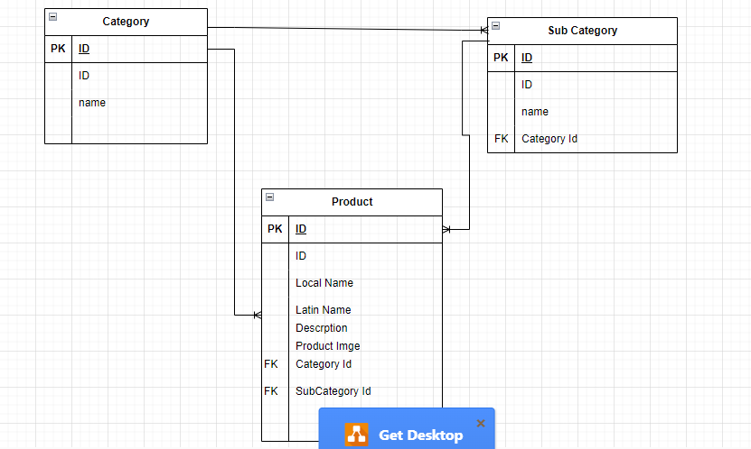

**2-If Sub Category Have Children (have category under sub category)**

